Institutional Repository
Lhamu Tshering Bhutia
Department of Political Science

2016
“Debates on Compulsory Voting and Its Applicability in india”, Voice of Intellectual Man”, Print ISSN: 2231-6914 On Line ISSN: 2319-4308.

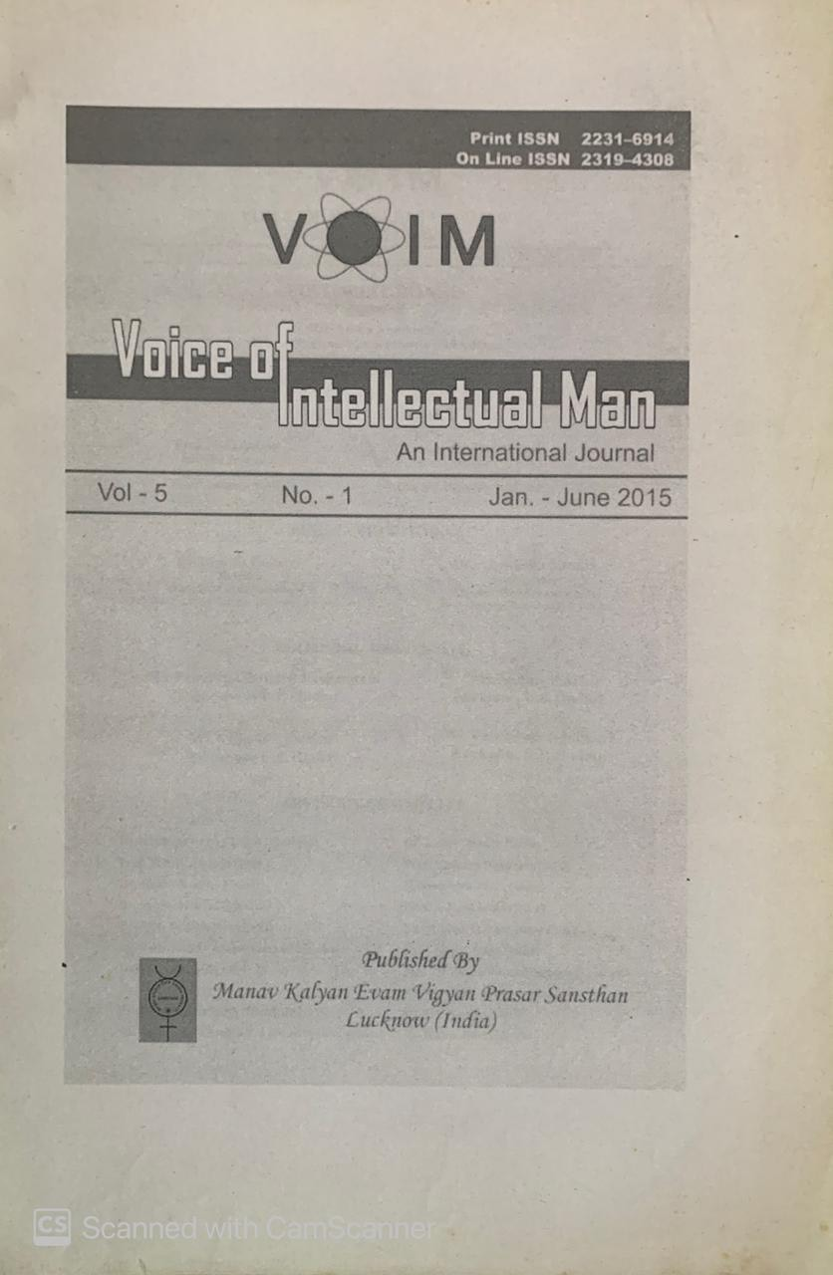

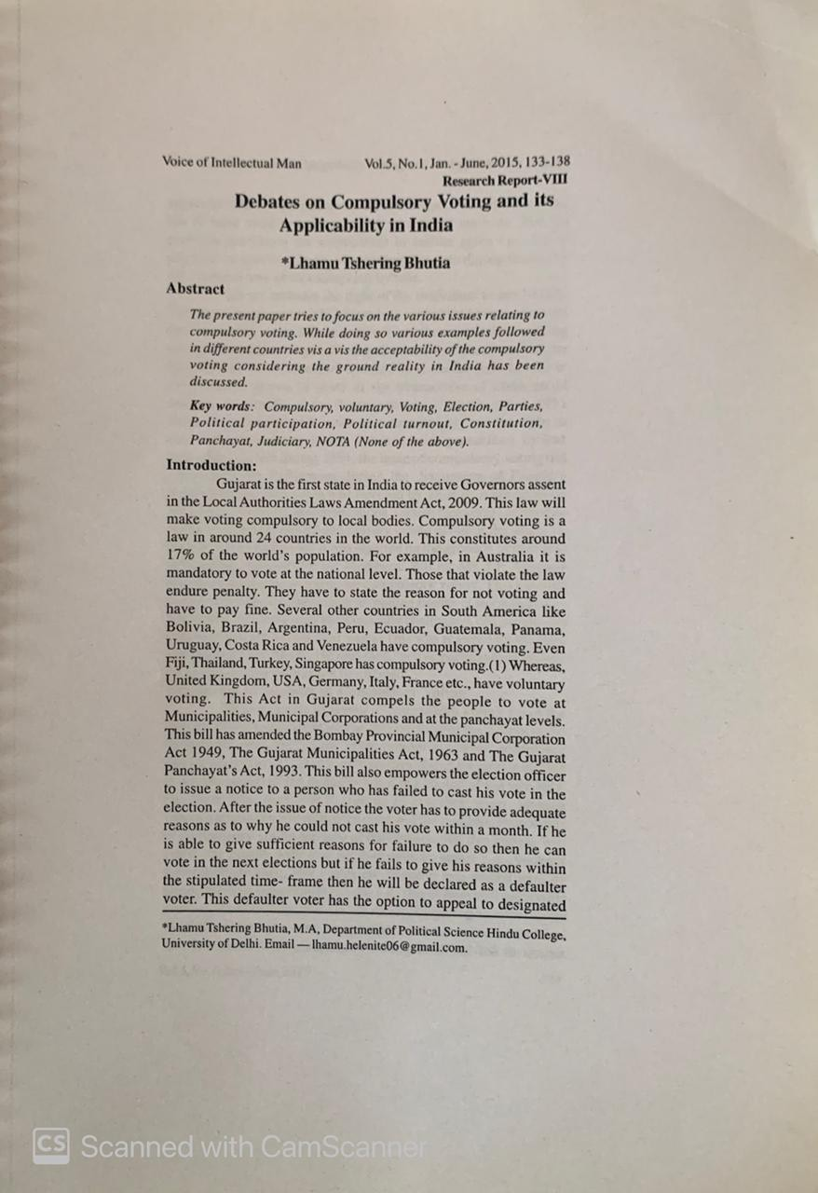

2019
- “Geopolitics of Bhutan and its Importance”, The West Bengal Political Science Review, ISSN: 2230-8296.

